**Experiment no. 1: To implement Insertion Sort and Comparative analysis the large values of ‘n’.**

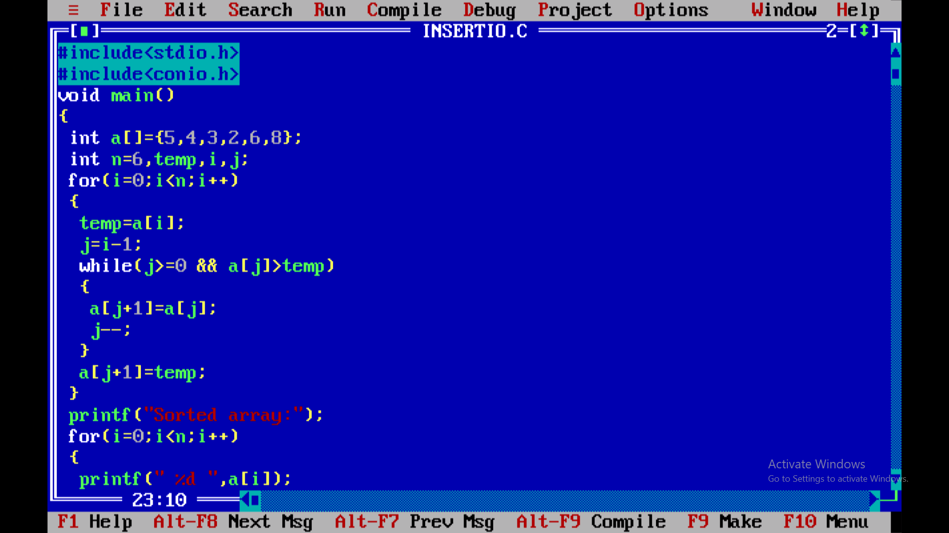

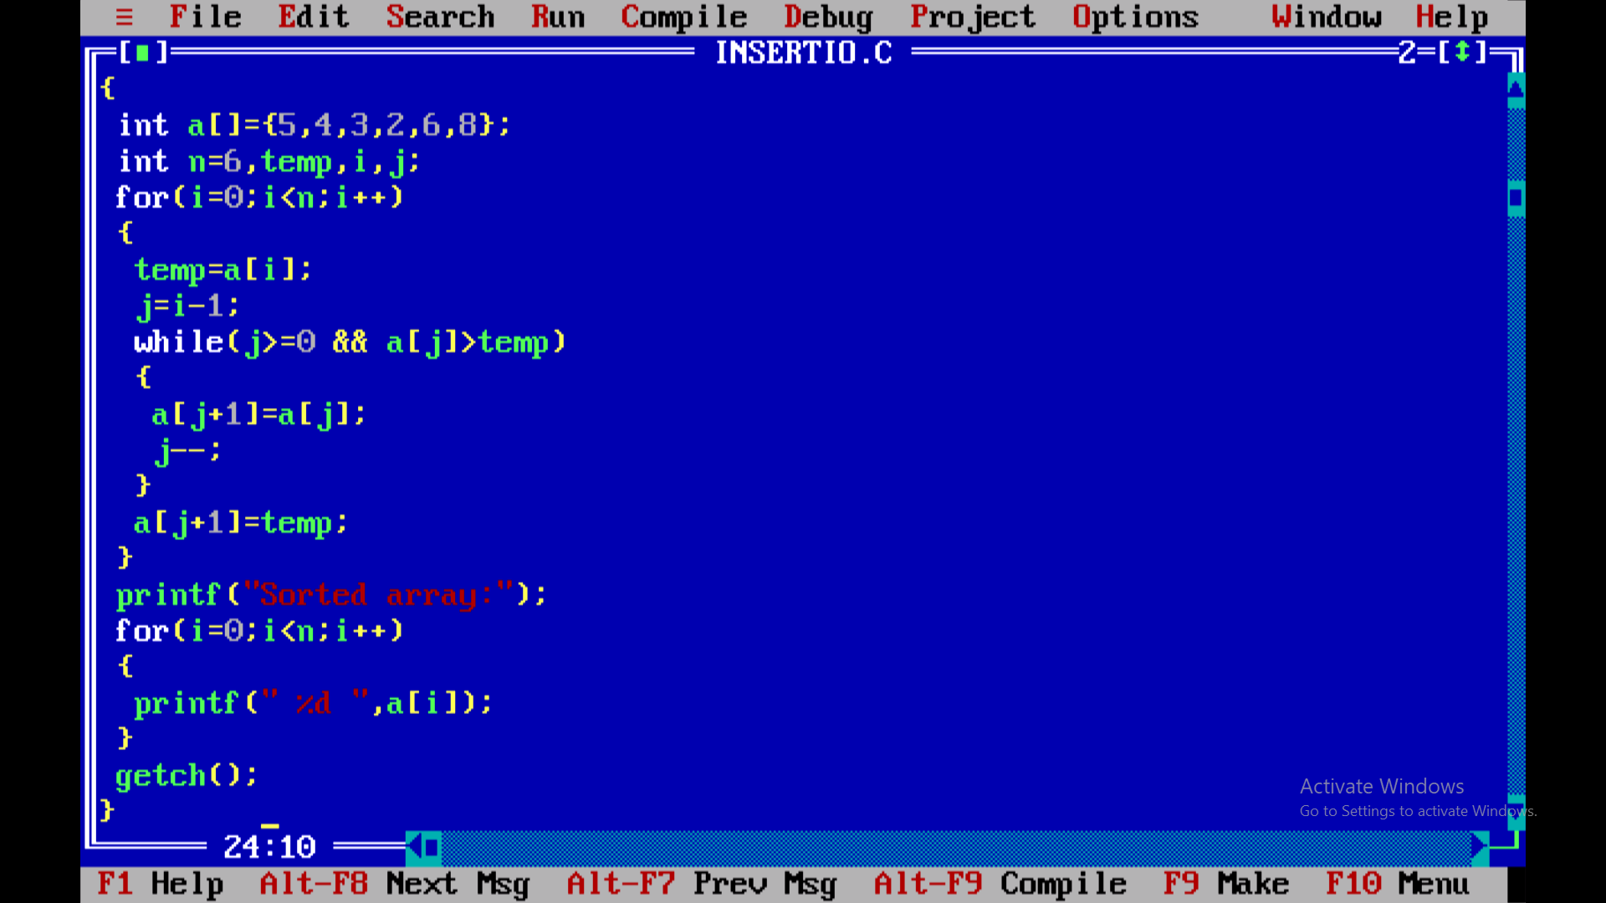

**Output:**

